- After listening to the flocabulary video on the five elements of a short story. Students will identify those key elements. https://www.flocabulary.com/fivethings/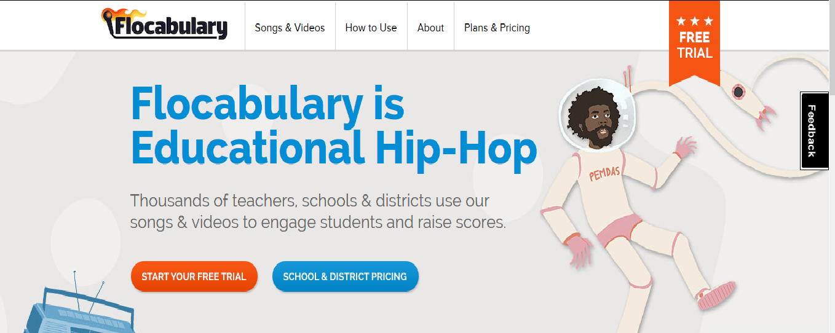
The benefits of this website, is that the students will get the chance to watch videos in order to find the elements that go into a story. The challenges of this tool are that it might be too easy for the age range, and students might not get any knowledge from it. The relation between the tool and the objective are evident in finding the key elements of a story.

- Students will construct an outline of their short story. The student will use each element to create the background to their story. Students then will illustrate a book cover for their story. Students will do a rough draft of their story for homework. Students will use http://www.readwritethink.org/files/resources/interactives/bookcover/ to get started on illustrating.
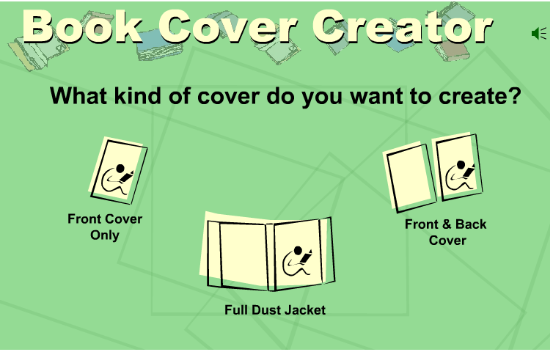
The benefits of this tool are for the students to get an extra push in creating. The tool guides the students in creating a front, front-back, and a full dust jacket. The challenges of this tool will be that the students will take too much time creating and not writing. This tool correlates with the learning objective because the students are creating.

- Students will explain their outline and illustration through a presentation to the class. The best Illustration gets displayed in the English corner. Students will go over the public speaking tutorial on Sophia. http://www.sophia.org/tutorials/speaking-in-class
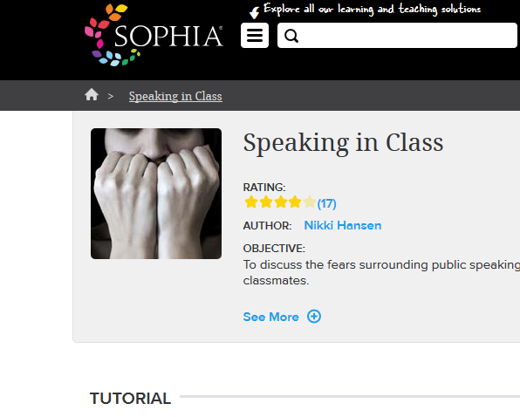
The benefits of this tool are that the students can get some extra tips on public speaking. The challenges of this tool are that the student will still be afraid to speak in front of the class and not take in any of the knowledge this tool gives. This tool correlates with the objective because it deals with public speaking.

- After switching stories with a peer; students will evaluate the story for errors, recommend revision or enhancements, and compare the story to the short story writing rubric. Students will also compare similarities to their own stories if any. Students will provide a number according to the rubric (1-4).
  - The tool for this objective is the short story rubric. The students will have a print out of this rubric, and will complete. The students will then turn in this rubric for a grade. The benefits of this tool serve as a guide for students to follow. It is easy for the students to follow something that they have in front of them. The challenges of this tool are that the students might not give the proper rating for their peers. The tool and the objective are related in the sort that the tool is needed for the students to complete the objective.
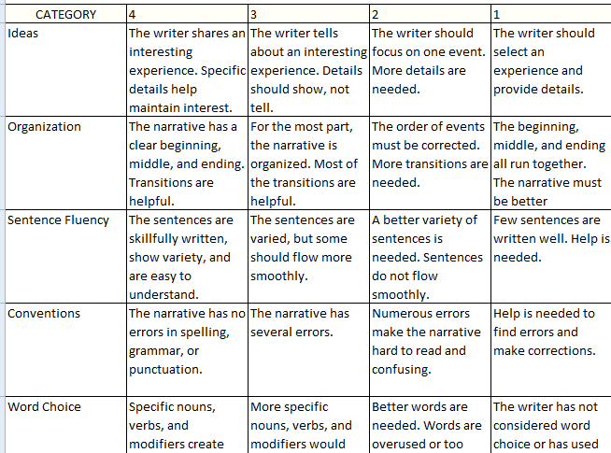

- After peer feedback students will integrate changes or enhancements, and create their final draft; including illustration.
No tool necessary.

